Electrical Parts Selection

Various electrical components had to be selected for full functionality of the project; the reasons for the parts selected are given in the document sections below.

The functionality requirements of the electrical design of a PCB (Printed Circuit Board) include:

* Interfacing with the Jetson Nano GPIO
* Powering the Jetson Nano
* Allowing Jetson Nano to control the actuators (motors)
* Powering the actuators (motors)
* Lighting of the specimen for image detection
* Reliable connections at all points

The general process for selecting a part is as follows, and any time this process is not followed is clearly listed in the relevant section.

1. Identify requirements of the individual parts due to project parameters
2. Browse DigiKey using appropriate filters
3. Sort by cost and select the cheapest appropriate option

Searches all occurred on DigiKey because of the many available options and ordering >100CAD of stock from them provides free shipping. If this project moves to a manufacturing phase where large amounts of stock would be purchased together then cost should be considered more seriously and alternative suppliers should be perused for cheaper options that fulfill design needs.

Finally, the selected parts’ DigiKey links and datasheets are available in the Electrical Detail Design Datasheets folder, within the subfolder named after the particular part’s desired function.

# Jetson Nano GPIO Interface

The Jetson Nano has 2 rows of 20 male header pins that contain 22 GPIO pins, per Figure 1. Controls established a desire for the pins to be accessible even after being connected to the final PCB in case any use is desired that is not in the initial circuit concept. Additionally, this is useful for debugging and probing.

Power will also be supplied to the Jetson Nano via two pins (pins 2&4 of the 2x20 header) at 5V and 2.5A each.

To meet the above requirements, headers were identified that would connect to the Jetson Nano, the circuit board being designed, and continue to male headers on the opposite side of the circuit board from the Jetson Nano for further pin availability.

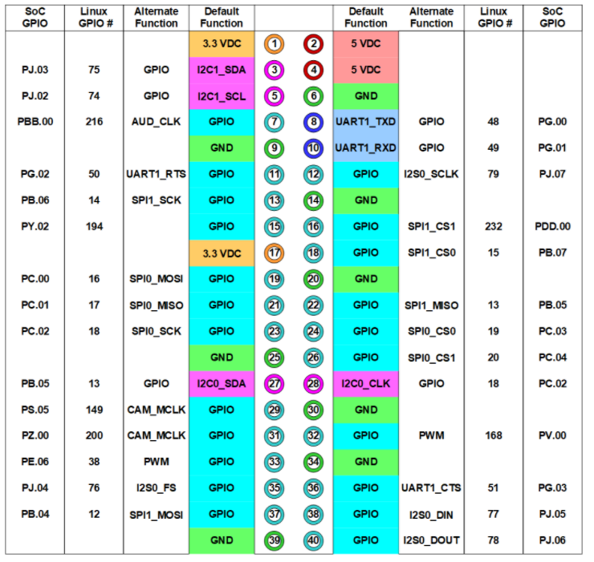

Figure 1: Jetson Nano 2GB GPIO [1]

# Lighting

Lighting of the specimen that the Image recognition algorithm attempts to identify cannot be guaranteed, so lighting will be included in the electrical design. The selected LED strip operates at 12 V, one of the two voltages available in the circuit, and 0.660 A. It is flexible and therefore easy to mount, and connects to the circuit board using only Vin and GND connections.

Resistors controlling the current through the LED are included within the part, so the only external part necessary is a transistor for control of the brightness of the LED strip. If the transistor is placed between the LED strip and GND, then a digital signal with variable duty cycle (i.e. Pulse Width Modulation or PWM) can control the brightness of the LED strip. The requirements of this transistor are that its maximum drain-to-source voltage is 12 VDC or greater, it can handle 660 mA or more of current, it has as low of a voltage drop across it as possible, 3.3 V digital logic will switch it on and off, and it can switch fast enough to keep up with the PWM signal.

The selected connector for the lighting is a simple male-female header connection, where the female header will be on the PCB. This is because header pins are very simple, cheap connections, and if the LED strip should come loose, the user can safely reconnect it; 12 VDC is a safe voltage for a person to touch, and putting the female header on the PCB prevents 12 V and GND from shorting if the user should intervene. The PCB should also be marked for polarity, although accidentally connected the LED strip in reverse will not damage it.

# Actuators

Mechanical selected the stepper motor that will be used since it satisfies mechanical design needs.

The stepper motor connects to circuits with wire leads, rather than JST connectors which are common for stepper motors. The connectors selected to connect the motor reliably to the board are tab connectors, which are very simple but reliable – they can handle relatively high power applications (this stepper motor is low power), they are cheap, they are secure.

Motor driver selection followed a different process than selection of most other parts: Adafruit is the manufacturer of the stepper motor and suggested an Arduino shield for controlling the motor. The controller of this project (Jetson Nano) is not an Arduino and not compatible with the Arduino shield, so the motor driver selected is in fact the modular form of the circuit implemented on that shield. Each driver module can control either two DC motors or one stepper motor.

The motor drivers are intended to be daughter circuit boards of the main PCB. Therefore, male header pins are connected directly to the daughter circuit boards in the available locations for header soldering, and female headers are a part of the main PCB design (header connections are more reliable when many pins are connecting two separate bodies; for an example, see Arduino shields). Thus, the stepper motor driver circuits may be safely added and removed from the main PCB as desired. 6- and 10-pin male and female header rows are selected to allow for these connections.

To ensure that the motor drivers are not damaged, fuses were selected as overcurrent protection – the driver description document suggests that it can handle 3 A for up to 20 ms, so a fast blow 3 A surface mount (replacement not expected to be required – motors should operate at <3 A at almost all times) fuse with the constant $I^{2}t=0.19$ since for the operating conditions $I^{2}t=3^{2}(0.020)=0.18$.

Stepper motors have no feedback control and thus their accurate steps may stray over long periods of time. To compensate for this flaw, limit switches have been selected to include in the design to detect when the bottom doors of the product are fully closed, which gives the Jetson Nano (which controls the stepper motors) a reference position.

The limit switch connector will be selected shortly, but it seems prudent to wait on this selection until Mechanical decides where and how the limit switch will be mounted in the device. Regardless, the limit switch will be connected to the circuit via two wires to header pins for the same reasons as the LED.

# Power Distribution

Power calculations are included in the document “Lithgow_PowerCalculations.docx” in the Electrical Detailed Design Communication folder on Microsoft Teams for MTE 380 Group 13.

The board-mount DC-DC converter selected is able to supply 5 V from a 12 V rail as efficiently as possible, supporting 25.15 W and 5.03 A (refer to power calculations) demand from its 5 V output.

The DC-DC converter datasheet remarks the necessity of a 9.5 A (maximum) fuse on the input to the converter. The maximum expected current draw of this converter, assuming extreme inefficiencies1 worse than those reported in the datasheet, is ~5.5 A (5.03 A + stepper motor driver current draw at 5 V), so any fuse between 5.5 A and 9.5 A is acceptable. Surface mount fuses are available and, since failure of this part is not expected and surface mount fuses are the cheapest option, the cheapest surface mount fuse (7.5 A) was selected.[1]

The document “Lithgow_ConverterComponentCalculations.docx” includes the calculations for the resistor and capacitor values surrounding the DC-DC converter. These resistors and capacitors are filtered on DigiKey according to these values and other power, voltage, and current requirements based on their locations in the circuit (capacitors have a breakdown voltage, and resistors can only dissipate a limited amount of power).

Based on power calculations, the wall AC to 12 V DC transformer must be able to deliver 49 W. Several transformers are sold separately from the part that plugs into the wall power, so the selected transformer is one of the cheapest options available once this is considered, and the datasheet suggests various blades that they produce for the connection to the outlet. This has the added benefit that the device being designed may be marketed to global consumption.

The transformer’s wire ends in a female barrel, so a barrel jack with matching dimensions was selected for connecting to the PCB.

# Cautions:

It may be possible for the user to short two pins of the Jetson Nano if male header pins are accessible. Consider swapping out the 2x20 female-male header array for a 2x20 female-female header array to decrease the likelihood of this occurrence.

# References

[1] <https://developer.nvidia.com/embedded/learn/jetson-nano-2gb-devkit-user-guide#id-.JetsonNano2GBDeveloperKitUserGuidevbatuu_v1.0-PowerConsumption>

1. 1: voltage is reduced by power dissipation (i.e. resistor action)